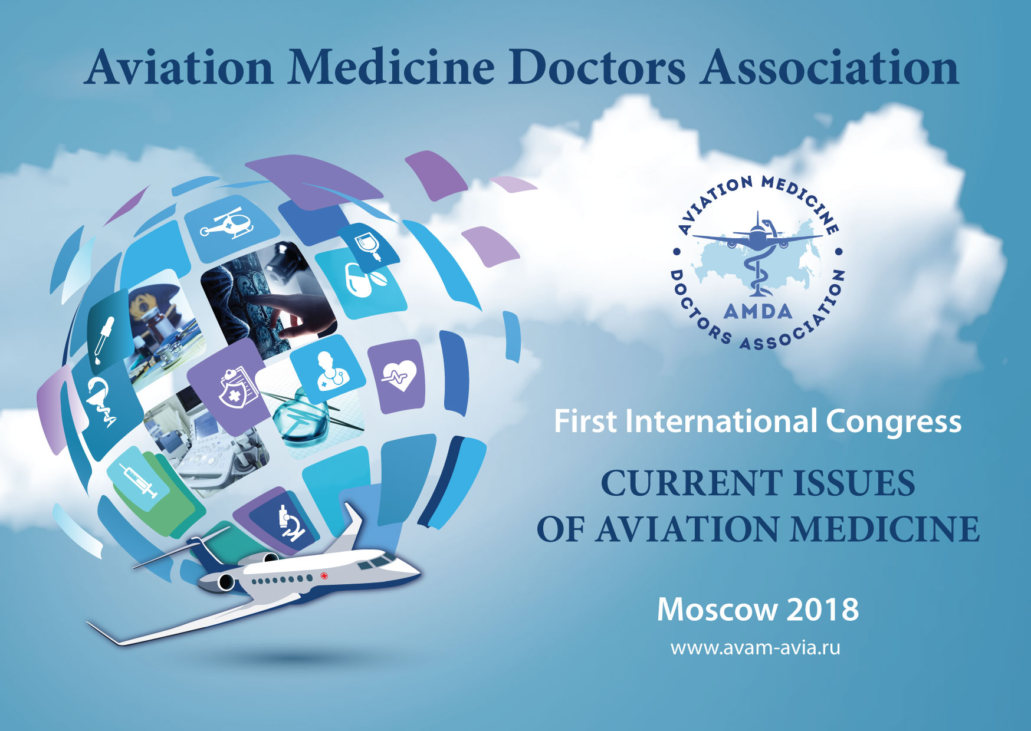

Dear Colleagues and Partners!

**We warmly invite you to The First Congress AMDA «Current issues of Aviation Medicine» Moscow, October 17-19, 2018**

**Title**: The First Congress AMDA «Current issues of Aviation Medicine»

**When:** 17-19 October, 2018

**City:** Moscow

**Organizer:** Aviation Medicine Doctors Association AMDA *

**Supported by:** European Society of Aerospace Medicine ESAM

**Technical organizer:** «Medicine Today» Co, Ltd.

**Audience:** Medical aviation examiners of Flight Expert Medical Commissions and aerospace medical

practitioners, physicians, cardiologists, ophthalmologists, psychologists, neurologists, surgeons,

endocrinologists, tuberculosis coordinators, oncologists, urologists, psychiatrists as well as functional diagnosis

and lab specialists.

**Number of participants:** 200

In frames of the Congress - Exhibition of manufacturers and distributors of pharmaceutical drugs, treatment

and diagnostic equipment, nutrition and biological active supplements, protective and emergency kits as well as

software packages and devices for Aviation Medicine.

**Website:** [www.avam-avia.ru](http://www.avam-avia.ru)

«Current issues of aviation medicine»

The Draft Program

1. Medical flight expert assessment in civil aviation at its current stage.

1.1. Policies and regulations in the Russian Federation, accomplishment of the tasks assigned by the President of the Russian Federation on 29/04/2016

№ 800.

1.2. Monitoring and analysis of health fitness of civil aviation personnel.

1.3. Clinical aspects of medical flight assessment: examination protocols and medical evaluation criteria on civil aviation aircrew members with chronic illnesses.

1.4. Treatment and rehabilitation of civil aviation personnel affected by different kinds of illnesses. Medical clearance for aviation duties after treatment and rehabilitation.

1.5. The order of establishment and designation of Flight Expert Medical Commissions of Civil Aviation.

1.6. Existing Training programs on required competence in aviation medicine and medical flight expertise provided for Chairmen of Flight Expert Medical Commissions and designated medical examiners.

1.7 Data evaluation and risk management in Flight Safety System.

2. Medical dynamic supervision and follow-up monitoring of civil aviation personnel within the period between examinations performed by responsible aviation medicine practitioners of airlines.

2.1. Fostering healthy lifestyle and delivering preventive procedures to civil aviation personnel.

3. Medical provision of flight operational safety.

3.1. In-flight medical emergencies. Strategies and procedures of medical assistance for passengers.

3.1.1. Medical clearance to meet applicable requirements for passengers.

3.2. First aid medical equipment and supplies for aircrafts.

3.3. Reasons for grounding at pre-flight medical check-ups.

4. Collaboration between Aviation Medicine Doctors Association (AMDA) and European Society of Aerospace Medicine (ESAM).

4.1. Report from ESAM President on activities of the European Society of Aerospace Medicine.

4.2. Main scientific goals of ESAM (Advisory Board Committee report).

4.3. Joint meeting of ESAM (EC) Executive Committee and АВАМ Presidium.

**In frames of the Congress there will be the Exhibition of manufacturers and distributors of pharmaceutical drugs, treatment and diagnostic equipment, nutrition and biological active supplements, protective and emergency kits as well as software packages and devices for Aviation Medicine.**

**FORMS OF PARTICIPATION IN THE CONGRESS**

|  |  |
| --- | --- |
| **THE GENERAL SPONSOR** | **7200 EUR** |

1. Participation in the scientific program with a report (20 min.).
2. Branded exhibition stand (3 sq. m).
3. Posting the logo on the site of the organizer, indicating the status.
4. Company logo on badge ribbons for participants.
5. Posting the information about the company in the event program (logo, short title).
6. Posting the advertising module (one page, 4th cover) in the workbook.
7. Distribution of information / promotional materials among participants (in delegate’s bags, not more than 5 pages А4 size).
8. Installation of 2 roll-ups at the exhibition zone (size 1*2 m, the place of installation should be agreed with organizer).
9. Note the sponsor in the e-mail invitations for the event.

10. Participation of the company representatives is unlimited.

|  |  |
| --- | --- |
| **SPONSOR I** | **4400 EUR** |

1. Branded exhibition stand (3 sq. m).
2. Posting the logo on the site of the organizer, indicating the status.
3. Posting the information about the company in the program of the event (logo, short title).
4. Posting the advertising module (one page, 3th cover) in the workbook.
5. Distribution of information / promotional materials among participants (in delegate’s bags, not more than 5 pages А4 size).
6. Installation of 2 roll-ups at the exhibition zone (size 1*2 m, the place of installation should be agreed with organizer).
7. Note the sponsor in the e-mail invitations for the event.
8. Invitation for 4 company representatives.

|  |  |
| --- | --- |
| **SPONSOR II** | **2200 EUR** |

1. Branded exhibition stand (2 sq. m).
2. Posting the logo on the site of the organizer, indicating the status.
3. Posting the information about the company in the program of the event (logo, short title).
4. Posting the advertising module (one page, inside covers) in the workbook.
5. Distribution of information / promotional materials among participants (in delegate’s bags, not more than 5 pages А4 size).
6. Installation of 2 roll-ups at the exhibition zone (size 1*2 m, the place of installation should be agreed with organizer).
7. Note the sponsor in the e-mail invitations for the event.
8. Invitation for 3 company representatives.

|  |  |
| --- | --- |
| **EXHIBITOR** | **1200 EUR** |

1. Exhibition of a workplace (1 table, 2 chairs, socket, basket of garbage).
2. Placement of information about the company in the program of the event (logo, short title).
3. Invitation for 2 company representatives.

**ADDITIONAL FORMS OF PARTICIPATION IN THE CONGRESS**





*Aviation Medicine Doctors Association (AМDA) was established to provide comprehensive assistance within aviation community in developing aviation medicine and exchanging research results and experience both throughout the Russian Federation and globally.

The activities of The Association (AМDA) encompass interaction with governmental bodies and Federal Air Transport Agency “Rosaviatsiya” as well as The Ministry of Healthcare of the Russian Federation and Occupational safety centers on health issues of flight operational safety.

The Association represents interests of Russian medical practitioners in different specializations who are involved into medical provision of flight operational safety of Civil Aviation, medical assessment, flight-expert medical examination and licensing for fitness to perform aviation duties.

The main goals of the Association are collaborating and coordinating the activities performed by its members which are aimed at boosting national aviation medicine, increasing flight operational safety and defending the rights of the association members in governmental and non-governmental institutions, federal, regional and local authorities as well as international organizations.

In 2018 АMDA is hosting the First Congress of Aviation Medicine with participation of European Society of Aerospace Medicine (ESAM). The purpose of the Congress is enhancing medical provision, developing preventive aviation medicine, fatigue risks management, supporting programs of health promotion of aviation personnel, providing their reliability and fitness that is crucially important in terms of flight safety.

For participation in Congress you can

contact Olga Verba

Vice-President

Aviation Medicine Doctors Association

Tel: +7 495 490 0391. Mob.: +7 906 907 1616.

E-mail: overba@mail.ru

and Olga Nikulina

Head of Partner Program Development

«Medicine Today» Co, Ltd.

Tel.+7 495 419 02 99, Mob.: +7 968 785 57 51

E-mail: nikulina@protiv-raka.ru